Planning your engineering drawing
Before starting your engineering drawing you should plan how you are going to make best use of the space. It is important to think about the number of views your drawing will have and how much space you will use of the paper.
- Try to make maximum use of the available space.
- If a view has lots of detail, try and make that view as large as possible. If necessary, draw that view on a separate sheet.
- If you intend to add dimensions to the drawing, remember to leave enough space around the drawing for them to be added later.
- If you are working with inks on film, plan the order in which you are drawing the lines. For example you don't want to have to place your ruler on wet ink

Lines and line styles
In the first tutorial we learnt how to create simple shapes using the place line tool. The lines we created were all of the same thickness and type. But lines on an engineering drawing signify more than just the geometry of the object and it is important that you use the appropriate line types.

Line Thickness
For most engineering drawings you will require two thicknesses, a thick and thin line. The general recommendations are that thick lines are twice as thick as thin lines.
A thick continuous line is used for visible edges and outlines.
A thin line is used for hatching, leader lines, short centre lines, dimensions and projections.

Line Styles
Other line styles used to clarify important features on drawings are:
Thin chain lines are a common feature on engineering drawings used to indicate centre lines. Centre lines are used to identify the centre of a circle, cylindrical features, or a line of symmetry. Centre lines will be covered in a little bit more detail later in this tutorial.
Dashed lines are used to show important hidden detail for example wall thickness and holes..

Dimensioning - An Overview
A dimensioned drawing should provide all the information necessary for a finished product or part to be manufactured. An example dimension is shown below.
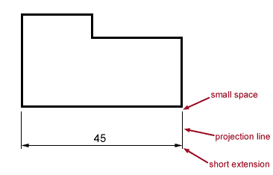
Dimensions are always drawn using continuous thin lines. Two projection lines indicate where the dimension starts and finishes. Projection lines do not touch the object and are drawn perpendicular to the element you are dimensioning.
In general units can be omitted from dimensions if a statement of the units is included on your drawing. The general convention is to dimension in mm's.
All dimensions less than 1 should have a leading zero. i.e. .35 should be written as 0.35

Lettering
All notes and dimensions should be clear and easy to read. In general all notes should be written in capital letters to aid legibility. All lettering should be of the same size and preferably no smaller than 3mm. An example typeface is shown below.
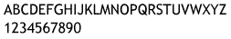

Types of dimensioning
Parallel Dimensioning  Parallel dimensioning consists of several dimensions originating from one projection line. | 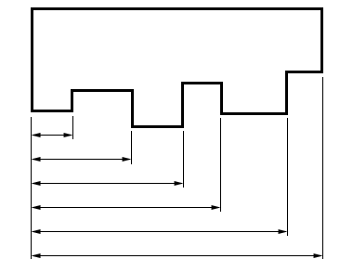
Superimposed Running Dimensions  Superimposed running dimensioning simplifies parallel dimensions in order to reduce the space used on a drawing. The common origin for the dimension lines is indicated by a small circle at the intersection of the first dimension and the projection line. In general all other dimension lines are broken.  The dimension note can appear above the dimension line or in-line with the projection line | 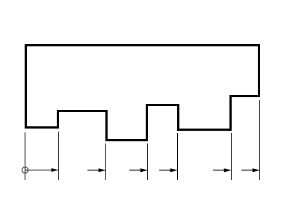
Chain Dimensioning  Chains of dimension should only be used if the function of the object won't be affected by the accumulation of the tolerances. (A tolerance is an indication of the accuracy the product has to be made to. Tolerance will be covered later in this chapter). | 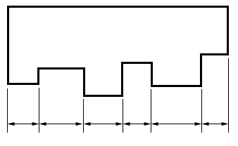
Combined Dimensions  A combined dimension uses both chain and parallel dimensioning. | 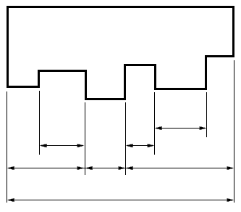
Dimensioning by Co-ordinates  Two sets of superimposed running dimensions running at right angles can be used with any features which need their centre points defined, such as holes. | 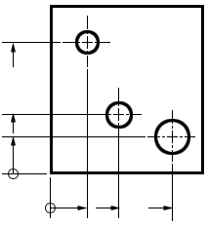
Simplified dimensioning by co-ordinates  It is also possible to simplify co-ordinate dimensions by using a table to identify features and positions. | 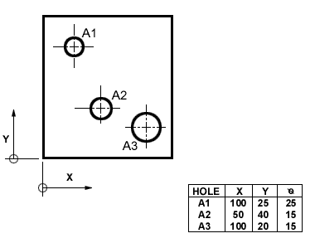

Dimensioning Small Features
When dimensioning small features, placing the dimension arrow between projection lines may create a drawing which is difficult to read. In order to clarify dimensions on small features any of the above methods can be used.

Dimensioning circles

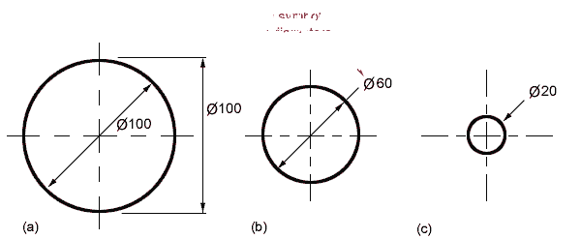
All dimensions of circles are proceeded by this symbol; . There are several conventions used for dimensioning circles:
(a) Shows two common methods of dimensioning a circle. One method dimensions the circle between two lines projected from two diametrically opposite points. The second method dimensions the circle internally.
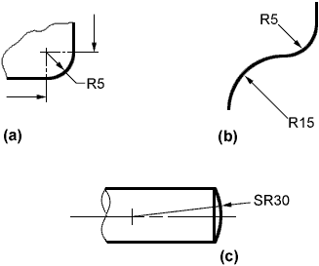
(b) Is used when the circle is too small for the dimension to be easily read if it was placed inside the circle. A leader line is used to display the dimension.
(c) The final method is to dimension the circle from outside the circle using an arrow which points directly towards the centre of the circle.
The first method using projection lines is the least used method. But the choice is up to you as to which you use.

Dimensioning Holes

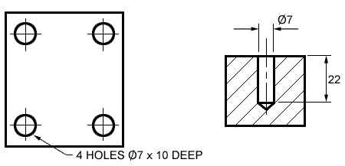
When dimensioning holes the method of manufacture is not specified unless they necessary for the function of the product. The word hole doesn't have to be added unless it is considered necessary. The depth of the hole is usually indicated if it is isn't indicated on another view. The depth of the hole refers to the depth of the cylindrical portion of the hole and not the bit of the hole caused by the tip of the drip.

Dimensioning Radii
All radial dimensions are proceeded by the capital R. All dimension arrows and lines should be drawn perpendicular to the radius so that the line passes through the centre of the arc. All dimensions should only have one arrowhead which should point to the line being dimensioned. There are two methods for dimensioning radii.
(a) shows a radius dimensioned with the centre of the radius located on the drawing.
(b) shows how to dimension radii which do not need their centres locating.

Spherical dimensions
The radius of a spherical surface (i.e. the top of a drawing pin) when dimensioned should have an SR before the size to indicate the type of surface.

Tolerancing
It is not possible in practice to manufacture products to the exact figures displayed on an engineering drawing. The accuracy depends largely on the manufacturing process used and the care taken to manufacture a product. A tolerance value shows the manufacturing department the maximum permissible variation from the dimension.
Each dimension on a drawing must include a tolerance value. This can appear either as:
- a general tolerance value applicable to several dimensions. i.e. a note specifying that the General Tolerance +/- 0.5 mm.
- or a tolerance specific to that dimension
The method of expressing a tolerance on a dimension as recommended by the British standards is shown below:
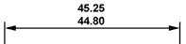
Note the larger size limit is placed above the lower limit.
All tolerances should be expressed to the appropriate number to the decimal points for the degree of accuracy intended from manufacturing, even if the value is limit is a zero for example.
45.25 | should not be expressed as | 45.25
44.80 |  | 44.8

The layout of an engineering drawing
It is important that you follow some simple rules when producing an engineering drawing which although may not be useful now, will be useful when working in industry.
All engineering drawings should feature an information box. An example is shown below.
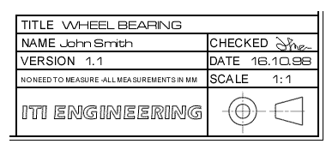

Common information recorded on an engineering drawing
TITLE
The title of the drawing.
NAME
The name of the person who produced the drawing. This is important for quality control so that problems with the drawing can be traced back to their origin.
CHECKED
In many engineering firms, drawings are checked by a second person before they are sent to manufacture, so that any potential problems can be identified early.
VERSION
Many drawings will get amended over the period of the parts life. Giving each drawing a version number helps people identify if they are using the most recent version of the drawing.
DATE
The date the drawing was created or amended on.
SCALE
The scale of the drawing. Large parts won't fit on paper so the scale provides a quick guide to the final size of the product.
PROJECTION SYSTEM
The projection system used to create the drawing should be identified to help people read the drawing. (Projection systems will be covered later).
COMPANY NAME
Many CAD drawings may be distributed outside the company so the company name is usually added to identify the source.

Orthographic projection
The aim of an engineering drawing is to convey all the necessary information of how to make the part to the manufacturing department. For most parts, the information cannot be conveyed in a single view. Rather than using several sheets of paper with different views of the part, several views can be combined on a single drawing using one of the two available projection systems, first angle, and third angle projection.
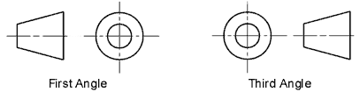
The diagram below demonstrates how the projection systems work
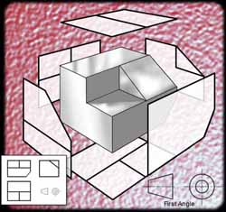
Top of Form

Bottom of Form

Sectioning - Introduction
Sections and sectional views are used to show hidden detail more clearly. They are created by using a cutting plane to cut the object.
A section is a view of no thickness and shows the outline of the object at the cutting plane. Visible outlines beyond the cutting plane are not drawn.
A sectional view, displays the outline of the cutting plane and all visible outlines which can be seen beyond the cutting plane. The diagram below shows a sectional view, and how a cutting plane works.
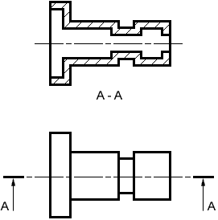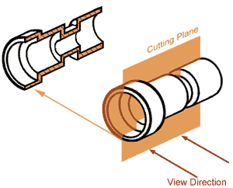

Types of sectioning

Sectional View in a single plane
The example below shows a simple single plane sectional view where object is cut in half by the cutting plane. The cutting plane is indicated on a drawing using the line style used for centre lines, but with a thick line indicating the end of lines and any change in the direction of the cutting plane. The direction of the view is indicated by arrows with a reference letter. The example below shows a sectional view of the cutting plane A - A.

Sectional View in two planes
It is possible for the cutting plane to change directions, to minimise on the number of sectional views required to capture the necessary detail. The example below shows a pipe being cut by two parallel planes. The sketch shows where the object is cut.
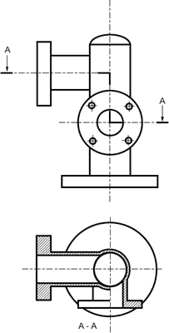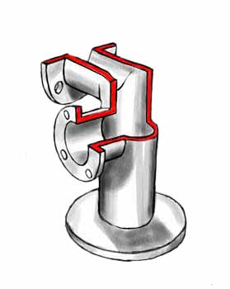

Half Sectional views
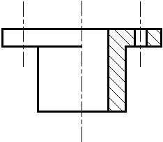
Half sections are commonly used to show both the internal and outside view of symmetrical objects.

Part Sectional views
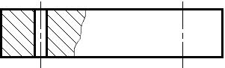
It is common practice to section a part of an object when only small areas need to be sectioned to indicate the important details. The example above shows a part sectional view to indicate a through-hole in a plate. Notice that the line indicating the end of the section is a thin continuous line.

Drawing threaded parts

Drawing Conventions
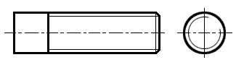  A threaded part | Threads are drawn with thin lines as shown in this illustration. When drawn from end-on, a threaded section is indicated by a broken circle drawn using a thin line.

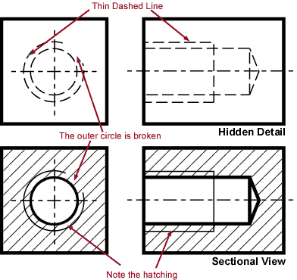 | Frequently a threaded section will need to be shown inside a part. The two illustrations to the left demonstrate two methods of drawing a threaded section. Note the conventions. The hidden detail is drawn as a thin dashed line. The sectional view uses both thick and thin line with the hatching carrying on to the very edges of the object.

Hatching
On sections and sectional views solid area should be hatched to indicate this fact. Hatching is drawn with a thin continuous line, equally spaced (preferably about 4mm apart, though never less than 1mm) and preferably at an angle of 45 degrees.

Hatching a single object
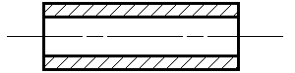
When you are hatching an object, but the objects has areas that are separated, all areas of the object should be hatched in the same direction and with the same spacing.

Hatching Adjacent objects
When hatching assembled parts, the direction of the hatching should ideally be reversed on adjacent parts. If more than two parts are adjacent, then the hatching should be staggered to emphasise the fact that these parts are separate.
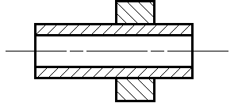 | 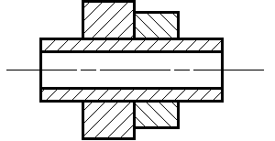
Reverse hatching | Staggered Hatching

Hatching thin materials
Sometimes, it is difficult to hatch very thin sections. To emphasise solid wall the walls can be filled in. This should only be used when the wall thickness size is less than 1mm
.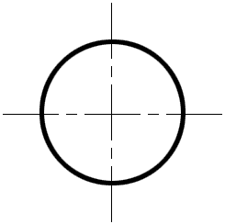

Hatching large areas
When hatching large areas in order to aid readabilty, the hatching can be limited to the area near the edges of the part.
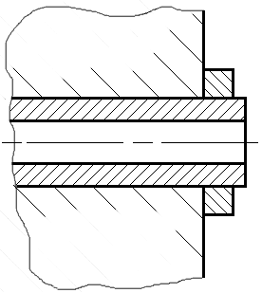

Assembly Drawings
The previous chapters covered the general aspects of engineering drawing and how to produce a detailed drawing of a single part with all the necessary information to make the part. The assembly of these parts is shown in an assembly drawing also known as a general arrangement.
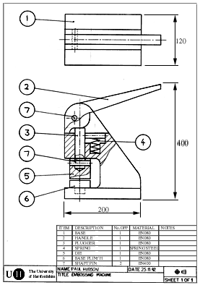 | Features of an assembly drawing  Dimensions  Detailed dimensions required for manufacture are excluded from assembly drawings. But overall dimensions of the assembled object are usually indicated.  If the spatial relationship between parts if important for the product to function correctly then these should also be indicated on the drawing. For example idicating the maximum and minimum clearance between two parts.  Internal Parts  If there are internal assemblies, sectional views should be used.  Parts list  Each part is given a unique number, indicated on the drawing by a circle with the number in it and a leader line pointing to the part. The leader line terminates in an arrow if the line touches the edge of the component, or in a circle if the line terminates inside the part.  A table of parts should be added to the drawing to identify each part, an example of a parts list is shown below:  The first three items; Item No., Description, and Quantity should be completed for every distint part on your drawing. (i.e. the number of duplicate parts are recorded in the quantity). The material is used for components that are being made within the company. The Remarks column is useful for specifying a manufacturers part number when using bough-in parts.
  Item No. | Description | Qty | Material | Remarks

An Overview of the Design Process

Design
Design is the process by which the needs of the customer or the marketplace are transformed into a product satisfying these needs. It is usually carried out a designer or engineer but requires help from other people in the company.
Design essentially is an exercise in problem solving. Typically, the design of a new product consists of the following stages:
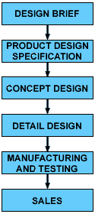
The development of a new product may also require the development of a prototype to prove that new technologies work before committing resources to full-scale manufacture.
The traditional view of the design to manufacture process is that it is a sequential process, the outcome of one stage is passed on to the next stage. This tends to lead to iteration in the design. I.e. having to go back to an earlier stage to correct mistakes. This can make products more expensive and delivered to the marketplace late. A better approach is for the designer to consider the stages following design to try and eliminate any potential problems. This means that the designer requires help from the other experts in the company for example the manufacturing expert to help ensure that any designs the designer comes up with can be made.
So what factors might a designer have to consider in order to eliminate iteration?
- Manufacture - Can the product be made with our facilities?
- Sales - Are we producing a product that the customer wants?
- Purchasing - Are the parts specified in stock, or do why have to order them?
- Cost - Is the design going to cost too much to make?
- Transport - Is the product the right size for the method of transporting?
- Disposal - How will the product be disposed at the end of its life?

Design Brief
The design brief is typically a statement of intent. I.e. "We will design and make a Formula One racing car". Although it states the problem, it isn't enough information with which to start designing.

Product Design Specification (PDS)
This is possibly the most important stage of the design process and yet one of the least understood stage. It is important that before you produce a 'solution' there is a true understanding of the actual problem. The PDS is a document listing the problem in detail. It is important to work with the customer and analyse the marketplace to produce a list of requirements necessary to produce a successful product. The designer should constantly refer back to this document to ensure designs are appropriate.
To produce the PDS it is likely that you will have to research the problem and analyse competing products and all important points and discoveries should be included in your PDS.

Concept Design
Using the PDS as the basis, the designer attempts to produce an outline of a solution. A conceptual design is a usually an outline of key components and their arrangement with the details of the design left for a later stage. For example, a concept design for a car might consist of a sketch showing a car with four wheels and the engine mounted at the front of the car. The exact details of the components such as the diameter of the wheels or the size of the engine are determined at the detail design stage. However, the degree of detail generated at the conceptual design stage will vary depending on the product being designed.
It is important when designing a product that you not only consider the product design specification but you also consider the activities downstream of the design stage. Downstream activities typically are manufacture, sales, transportation etc. By considering these stages early, you can eliminate problems that may occur at these stages.
This stage of the design involves drawing up a number of different viable concept designs which satisfy the requirements of the product outlined in the PDS and then evaluating them to decide on the most suitable to develop further. Hence, concept design can be seen as a two-stage process of concept generation and concept evaluation

Concept generation
Typically, designers capture their ideas by sketching them on paper. Annotation helps identify key points so that their ideas can be communicated with other members of the company.
There are a number of techniques available to the designer to aid the development of new concepts. One of the most popular is brainstorming.
This technique involves generating ideas, typically in small groups, by saying any idea that comes into your head no matter how silly it may seem. This usually sparks ideas from other team members. By the end of a brainstorming session there will be a list of ideas, most useless, but some may have the potential to be developed into a concept. Brainstorming works better if the members of the team have different areas of expertise.

Concept evaluation
Once a suitable number of concepts have been generated, it is necessary to choose the design most suitable for to fulfill the requirements set out in the PDS. The product design specification should be used as the basis of any decision being made. Ideally a multifunction design team should perform this task so that each concept can be evaluated from a number of angles or perspectives. The chosen concept will be developed in detail.
One useful technique for evaluating concepts to decide on which one is the best is to use a technique called 'matrix evaluation'
With matrix evaluation a table is produced listing important the features required from a product - usually this list is drawn up from the important features described in the product design specification. The products are listed across the table. The first concept is the benchmark concept. The quality of the other concepts are compared against the benchmark concept for the required features, to help identify if the concept is better, worse than, or is the same as the benchmark concept. The design with the most 'better than' is likely to be the best concept to develop further.
Most people who use the matrix technique will assign points, rather than simple, better, worse, same, so that it is easier to identify which concepts are the best. It is also likely that some features of the design will be more important than others so a weighting is used.

Detail design
In this stage of the design process, the chosen concept design is designed in detailed with all the dimensions and specifications necessary to make the design specified on a detailed drawing of the design.
It may be necessary to produce prototypes to test ideas at this stage. The designer should also work closely with manufacture to ensure that the product can be made.

